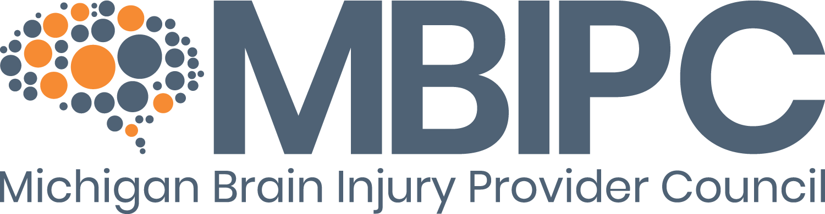
Monthly Educational Series
Sponsorship Information
As part of our commitment to education, the MBIPC hosts monthly professional development opportunities: Learn Over Lunch (2nd Tuesday of Every Month) and the Wednesday Webinar Series (4th Tuesday of Every Month).
Meetings are well attended, with representatives from provider organizations, case management companies and the insurance industry.
Sponsorship fee is $250 for virtual meetings, $400 for in-person meetings. Benefits include:
Virtual and In-Person  - Exclusive marketing privileges  - Acknowledgement in our monthly newsletter and flyer (with direct links to your website)  - Highlight in social media posts  - Five-minute presentation during the general business portion of the session | In-Person Only  - Exhibit space, with an eight-foot skirted table, is available upon request  - Handouts/brochures can be placed at each attendee’s seat  - Lunch for one, (extra lunches can be purchased at our $25 member rate)  - A prize drawing can be held to collect attendee information
Interested in Sponsoring? Follow this link
For more information, contact:
Tom Judd/(517) 896-2494/tom.judd@mbipc.org

